# of samples tested | # of samples with detectable fungicides | % of samples with detectable fungicides
632 | 33 | 5.22%
# of non-mig samples tested | # of non-mig samples with detectable fungicides | % of non-mig samples with detectable fungicides
442 | 20 | 4.52%
Neonics Analysis

(Method: summary stats)
2010-2013 | n | Mean | St. Dev | Min | Max | Percent infected at detectable level | Percent infected at threshold level | t-stat | p-value
Mites per 100 bees (Neonics) | 27 | 4.45 | 5.84 | 0 | 25.70 | 81.48% | 40.74% | -0.68 | 0.50
Mites per 100 bees (No neonics) | 548 | 5.23 | 5.86 | 0 | 37.16 | 91.79% | 53.28% | -0.68 | 0.50
Nosema per bee (Neonics) | 27 | 0.52 | 0.70 | 0 | 2.8 | 70.37% | 22.22% | 1.01 | 0.31
Nosema per bee (No neonics) | 546 | 0.35 | 0.90 | 0 | 10.8 | 47.62% | 10.99% | 1.01 | 0.31

Morbidity Summary Statistics (migratory + non-migratory)

(Method: Basic t-stats)

Morbidity Summary Statistics (non-migratory only)

2010-2013 | n | Mean | St. Dev | Min | Max | Percent infected at detectable level | Percent infected at threshold level | t-stat | p-value
Mites per 100 bees (Neonics) | 14 | 2.51 | 2.35 | 0 | 6.92 | 78.57% | 35.71% | -1.95** | 0.05
Mites per 100 bees (No neonics) | 386 | 5.66 | 6.02 | 0 | 37.16 | 94.30% | 58.03% | -1.95** | 0.05
Nosema per bee (Neonics) | 14 | 0.53 | 0.84 | 0 | 2.8 | 57.14% | 21.43% | 1.47 | 0.14
Nosema per bee (No neonics) | 386 | 0.26 | 0.65 | 0 | 5.75 | 43.01% | 9.07% | 1.47 | 0.14

(Method: Basic t-stats)

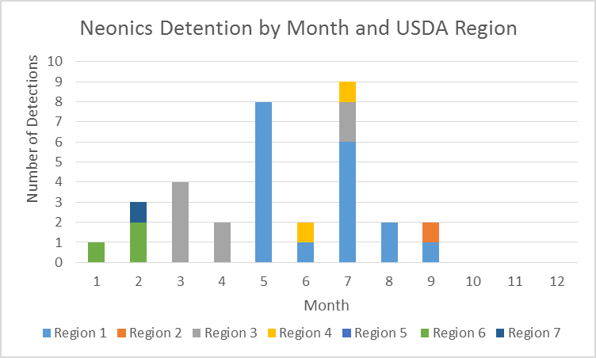
Detection Time and Location

Month | Count
Jan | 1
Feb | 3
Mar | 4
Apr | 2
May | 8
Jun | 2
Jul | 9
Aug | 2
Sep | 2
Oct | 0
Nov | 0
n=33

Neonic pesticides have been mainly detected from March to August and peaked in July. During the early months of the year (Jan to April), neonics were mainly found in warm areas such as California and Florida. Then, these pesticides have been detected in the Midwest (IL, IN, NE, IA, MN) from May to June. From July to September, neonics were detected mainly in colder states, such as NY, NJ and ND. Overall, USDA region 1 has been detected with the largest number (19 and 55.88%) of neonic pesticides.

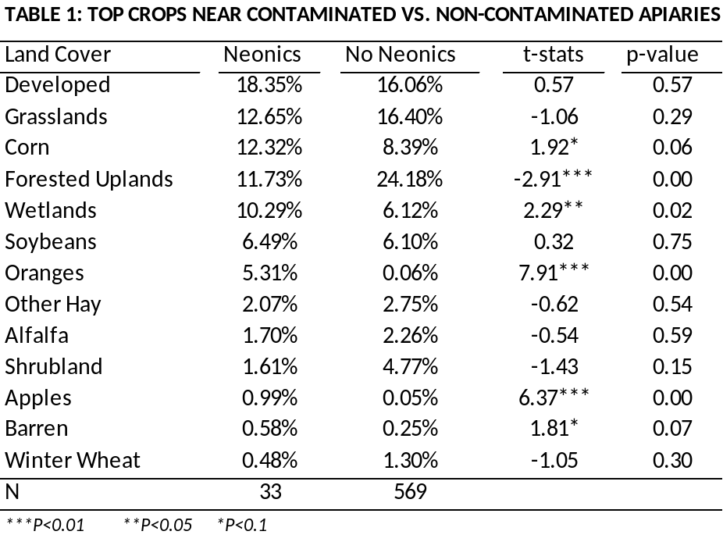

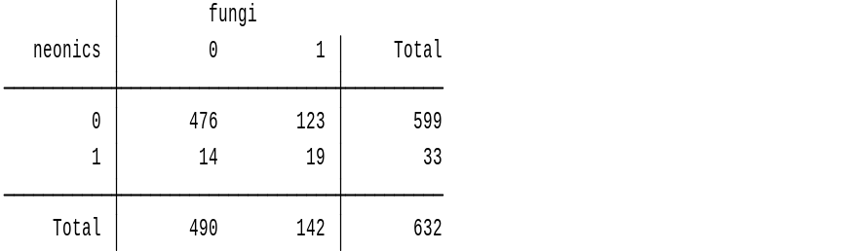

19 apiaries were contaminated by both pesticides

